Experiment:11 DATABASE WITH AUTO_INCREMENT
SEQUENCES

Aim
To create a database table using the AUTO_INCREMENT feature, which automatically generates a unique sequential number for the primary key whenever a new record is inserted.
Syntax
CREATE TABLE table_name (
column_name INT AUTO_INCREMENT PRIMARY KEY,
column2 datatype,
column3 datatype
);
Example
Create a Student table where Student_ID is automatically generated.
CREATE TABLE Student (
Student_ID INT AUTO_INCREMENT PRIMARY KEY,
Student_Name VARCHAR(50),
Department VARCHAR(50),
Marks INT
);
INSERT INTO Student (Student_Name, Department, Marks)
VALUES ('Ravi', 'CSE', 85);

INSERT INTO Student (Student_Name, Department, Marks)
VALUES ('Siva', 'ECE', 90);

INSERT INTO Student (Student_Name, Department, Marks)
VALUES ('Kiran', 'IT', 78);

Output:
SELECT * FROM Student;
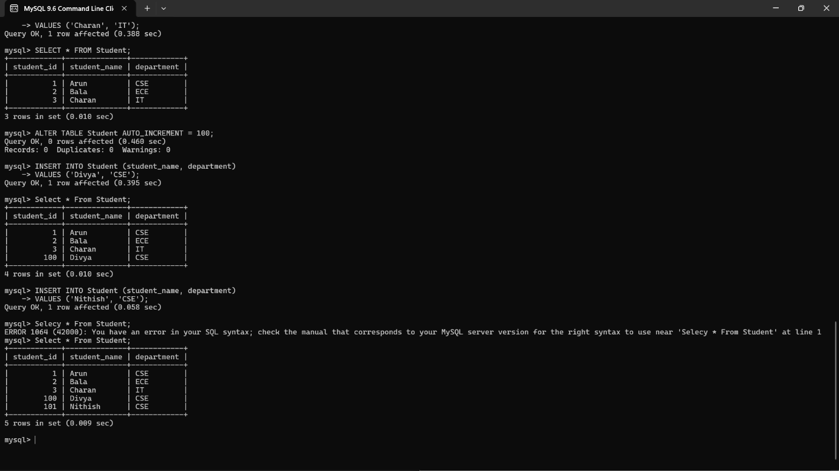

Result
Thus, the AUTO_INCREMENT feature was successfully implemented. The Student_ID values were automatically generated in sequential order whenever a new student record was inserted.

Experiment:12 Simple Programming using REPEAT, WHILE
Aim
To implement simple programs in MySQL/MariaDB using the WHILE and REPEAT loop statements.
1. Program Using WHILE Loop
Syntax
WHILE condition DO
statements;
END WHILE;
Example: Print numbers from 1 to 5
DELIMITER //

CREATE PROCEDURE PrintNumbers()
BEGIN
DECLARE i INT DEFAULT 1;

WHILE i <= 5 DO
SELECT i;
SET i = i + 1;
END WHILE;
END //

DELIMITER ;

Execute the Procedure
CALL PrintNumbers();
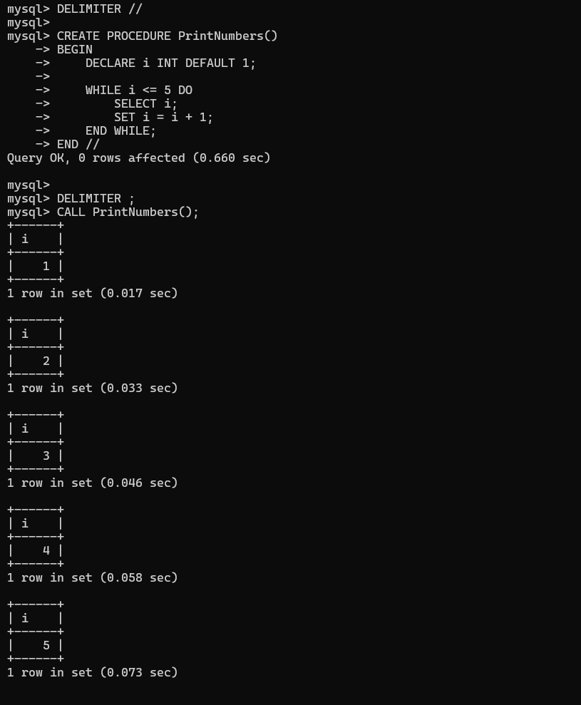
2. Program Using REPEAT Loop
Syntax
REPEAT
statements;
UNTIL condition
END REPEAT;
Example: Print numbers from 1 to 5
DELIMITER //

CREATE PROCEDURE PrintNumbersRepeat()
BEGIN
DECLARE i INT DEFAULT 1;
REPEAT
SELECT i;
SET i = i + 1;
UNTIL i > 5
END REPEAT;
END //
DELIMITER ;
Execute the Procedure
CALL PrintNumbersRepeat();
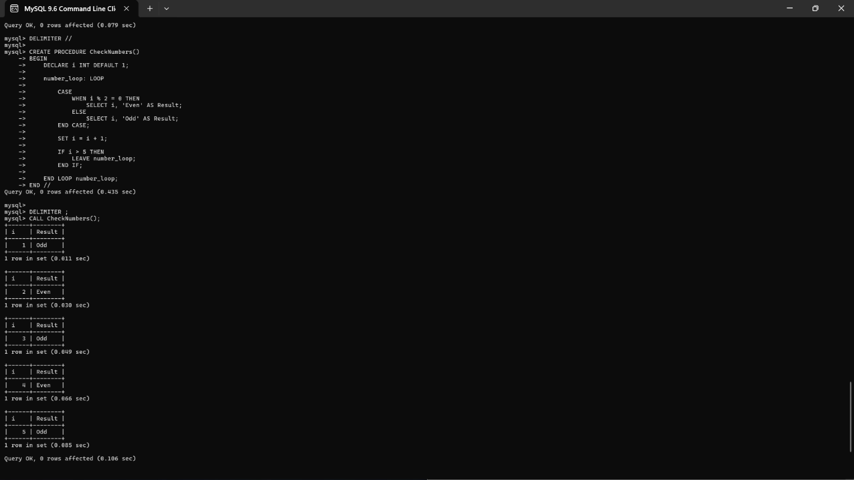
Result
Thus, simple programs were successfully implemented using WHILE and REPEAT loops in MySQL/MariaDB.
Experiment:13 Simple programming using CASE and LOOP

Aim
To learn how to use MySQL CASE and LOOP statements to execute a block of code repeatedly based on a condition.
Syntax of CASE
CASE
WHEN condition1 THEN statement1;
WHEN condition2 THEN statement2;
ELSE statement3;
END CASE;
Syntax of LOOP
LOOP
statements;

IF condition THEN
LEAVE loop_name;
END IF;
END LOOP;
Example Program Using CASE and LOOP
Program: Display numbers from 1 to 5 and classify them as odd or even.
DELIMITER //

CREATE PROCEDURE CheckNumbers()
BEGIN
DECLARE n INT DEFAULT 1;

number_loop: LOOP

CASE
WHEN MOD(n, 2) = 0 THEN
SELECT n AS Number, 'Even' AS Result;
ELSE
SELECT n AS Number, 'Odd' AS Result;
END CASE;

SET n = n + 1;

IF n > 5 THEN
LEAVE number_loop;
END IF;

END LOOP number_loop;
END //

DELIMITER ;
Execute the Procedure
CALL CheckNumbers();
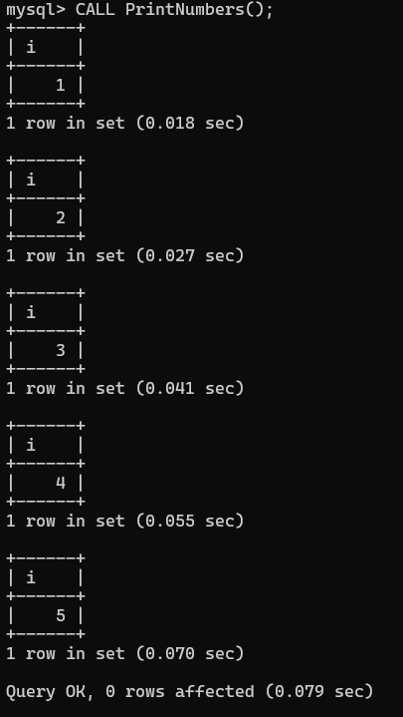

Result
Thus, the CASE and LOOP statements were successfully implemented in MySQL to repeatedly execute a block of code and classify numbers as Odd or Even.

Experiment: 14 TCL COMMANDS – COMMIT, SAVEPOINT,
ROLLBACK
Aim
To study and implement Transaction Control Language (TCL) commands such as COMMIT, SAVEPOINT, and ROLLBACK in MySQL/MariaDB for managing database transactions.

1. COMMIT
Purpose: Permanently saves all changes made during the current transaction.
Syntax:
COMMIT;
Example:
START TRANSACTION;

INSERT INTO Student VALUES (1, 'Ravi', 'CSE', 85);

COMMIT;
Result:
The inserted record is permanently saved in the database.

2. SAVEPOINT
Purpose: Creates a temporary point within a transaction to which we can roll back later.
Syntax:
SAVEPOINT savepoint_name;
Example:
START TRANSACTION;

INSERT INTO Student VALUES (2, 'Siva', 'ECE', 90);

SAVEPOINT sp1;

INSERT INTO Student VALUES (3, 'Kiran', 'IT', 78);
Result:
A savepoint named sp1 is created after inserting the second student.

3. ROLLBACK
Purpose: Cancels changes made after the specified savepoint or cancels the entire transaction.
Syntax:
ROLLBACK TO SAVEPOINT savepoint_name;
Example:
ROLLBACK TO SAVEPOINT sp1;

COMMIT;
The record inserted after sp1 is rolled back, while the record inserted before sp1 remains.

Complete Example
START TRANSACTION;

INSERT INTO Student VALUES (1, 'Ravi', 'CSE', 85);

SAVEPOINT sp1;

INSERT INTO Student VALUES (2, 'Siva', 'ECE', 90);

ROLLBACK TO SAVEPOINT sp1;

COMMIT;
Check the Result
SELECT * FROM Student;
Expected Result
Student_ID | Student_Name | Department | Marks
1 | Ravi | CSE | 85
The second record is removed because the transaction was rolled back to sp1.
Result
Thus, the TCL commands COMMIT, SAVEPOINT, and ROLLBACK were successfully implemented to control and manage transactions in the database.


Experiment: 15 DCL COMMANADS– GRANT, REVOKE
Aim
To study and implement Data Control Language (DCL) commands such as GRANT and REVOKE to provide and remove access privileges to database users.

1. GRANT
Purpose:
The GRANT command is used to give specific privileges to a database user.
Syntax
GRANT privilege_name
ON database_name.table_name
TO 'username'@'localhost';
Example
First, create a user:
CREATE USER 'student'@'localhost' IDENTIFIED BY 'student123';
Give the user permission to view the Student table:
GRANT SELECT
ON college.Student
TO 'student'@'localhost';
Result
The user student can now execute:
SELECT * FROM college.Student;

2. REVOKE
Purpose:
The REVOKE command is used to remove previously granted privileges from a user.
Syntax
REVOKE privilege_name
ON database_name.table_name
FROM 'username'@'localhost';
Example
Remove the SELECT privilege:
REVOKE SELECT
ON college.Student
FROM 'student'@'localhost';
Result
The user student can no longer execute:
SELECT * FROM college.Student;

Complete Example
CREATE USER 'student'@'localhost' IDENTIFIED BY 'student123';

GRANT SELECT, INSERT
ON college.Student
TO 'student'@'localhost';

REVOKE INSERT
ON college.Student
FROM 'student'@'localhost';
Final Privileges
User | Privilege
student | SELECT
student | INSERT – Revoked
Result
Thus, the GRANT and REVOKE DCL commands were successfully implemented to provide and remove database privileges for a user.

Output:
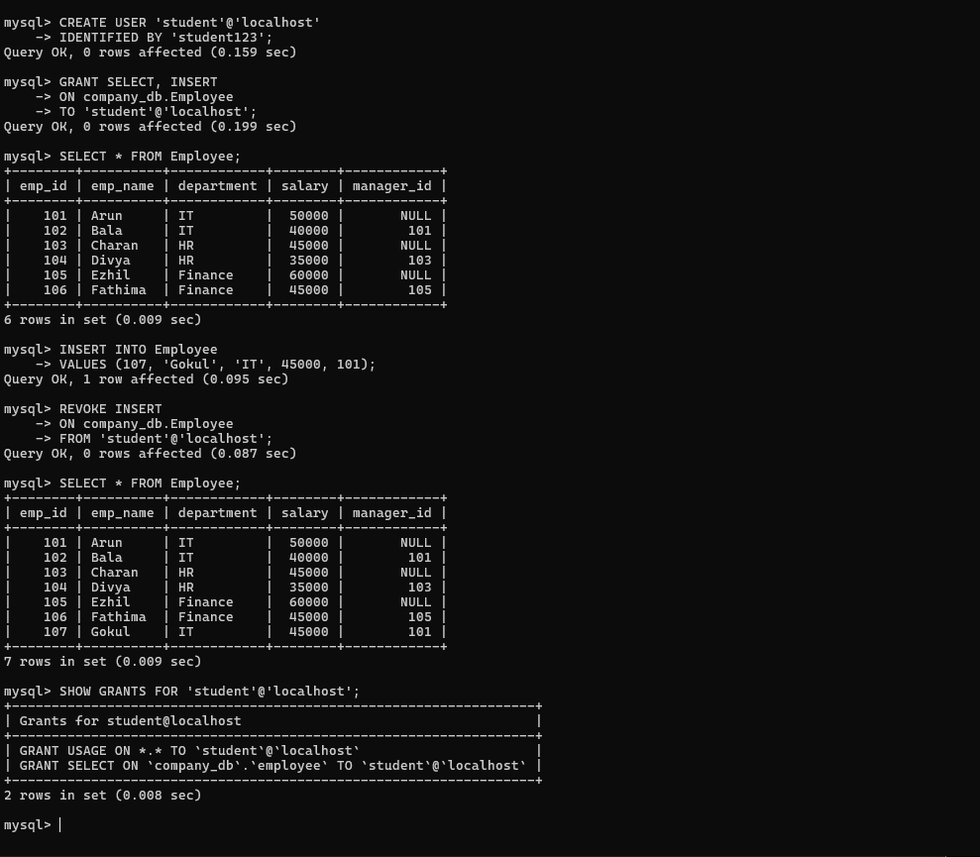

Experiment 16 HIGH LEVEL PROGRAMMING EXTENSIONS -
PROCEDURES

Aim
To learn and implement stored procedures in MySQL/MariaDB for performing a set of SQL statements as a reusable program.

Syntax
DELIMITER //

CREATE PROCEDURE procedure_name()
BEGIN
SQL statements;
END //

DELIMITER ;

Example
Create a procedure to display student details:
DELIMITER //

CREATE PROCEDURE DisplayStudents()
BEGIN
SELECT * FROM Student;
END //

DELIMITER ;
Execute the Procedure
CALL DisplayStudents();
Result
If the Student table contains:
Student_ID | Student_Name | Department | Marks
1 | Ravi | CSE | 85
2 | Siva | ECE | 90
3 | Kiran | IT | 78
The procedure displays all records from the Student table.

Example with Parameter
A procedure can also accept a parameter.
DELIMITER //

CREATE PROCEDURE GetStudent(IN sid INT)
BEGIN
SELECT *
FROM Student
WHERE Student_ID = sid;
END //

DELIMITER ;
Execute
CALL GetStudent(2);
Result
Student_ID | Student_Name | Department | Marks
2 | Siva | ECE | 90

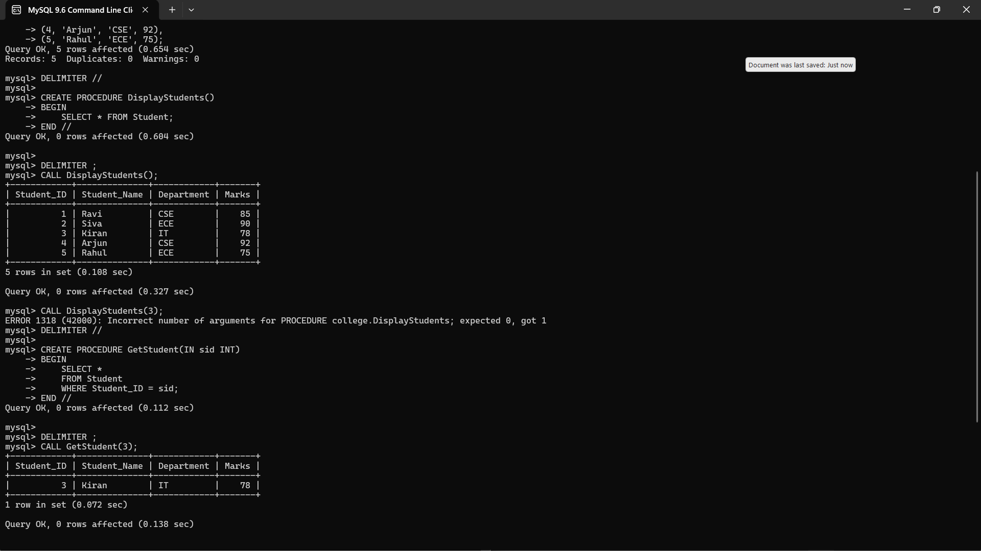

Result
Thus, a stored procedure was successfully created and executed to perform reusable SQL operations in the database.

Experiment: 17 HIGH LEVEL PROGRAMMING EXTENSIONS-
FUNCTIONS

Aim
To learn and implement user-defined functions in MySQL/MariaDB for performing calculations and returning a single value.
1. Create Database
CREATE DATABASE College;
USE College;
2. Create Table
CREATE TABLE Student (
Student_ID INT PRIMARY KEY,
Student_Name VARCHAR(50),
Department VARCHAR(30),
Marks INT
);
3. Insert Statements
INSERT INTO Student VALUES
(1, 'Ravi', 'CSE', 85),
(2, 'Siva', 'ECE', 90),
(3, 'Kiran', 'IT', 78),
(4, 'Arjun', 'CSE', 92),
(5, 'Rahul', 'ECE', 75);
4. Check the Table
SELECT * FROM Student;
Output
Student_ID | Student_Name | Department | Marks
1 | Ravi | CSE | 85
2 | Siva | ECE | 90
3 | Kiran | IT | 78
4 | Arjun | CSE | 92
5 | Rahul | ECE | 75

5. Create a Function
The following function calculates the grade based on marks.
Syntax
DELIMITER //

CREATE FUNCTION function_name(parameter datatype)
RETURNS datatype
DETERMINISTIC
BEGIN
statements;
RETURN value;
END //

DELIMITER ;
Example
DELIMITER //

CREATE FUNCTION GetGrade(mark INT)
RETURNS VARCHAR(10)
DETERMINISTIC
BEGIN
DECLARE grade VARCHAR(10);

IF mark >= 90 THEN
SET grade = 'A';
ELSEIF mark >= 75 THEN
SET grade = 'B';
ELSEIF mark >= 50 THEN
SET grade = 'C';
ELSE
SET grade = 'F';
END IF;

RETURN grade;
END //

DELIMITER ;
6. Execute the Function
SELECT Student_ID, Student_Name, Marks, GetGrade(Marks) AS Grade
FROM Student;
Result
Student_ID | Student_Name | Marks | Grade
1 | Ravi | 85 | B
2 | Siva | 90 | A
3 | Kiran | 78 | B
4 | Arjun | 92 | A
5 | Rahul | 75 | B
7. Simple Function Example
A function to calculate the square of a number:
DELIMITER //

CREATE FUNCTION SquareNumber(n INT)
RETURNS INT
DETERMINISTIC
BEGIN
RETURN n * n;
END //

DELIMITER ;
Execute
SELECT SquareNumber(5) AS Square;
Output
Square
25
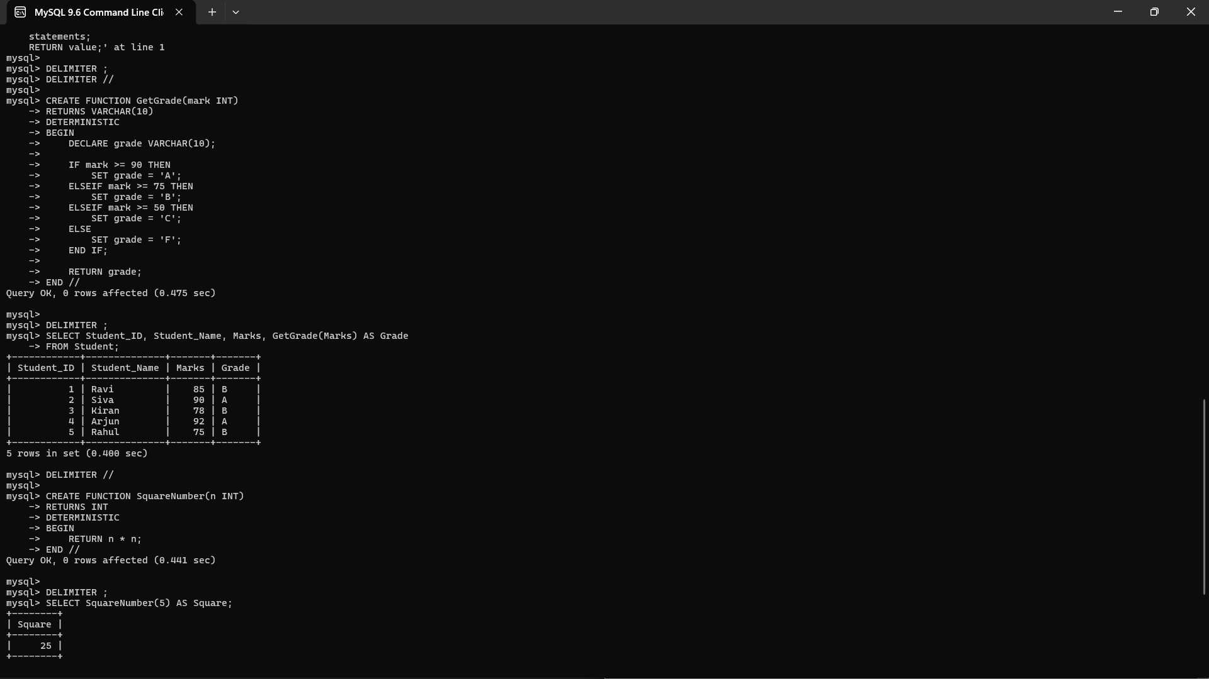

Result
Thus, the user-defined functions were successfully created and executed in MySQL/MariaDB to perform calculations and return values.
Experiment: 18 HIGH LEVEL LANGUAGE EXTENSION WITH
CURSORS
Aim
To learn and implement cursors in MySQL/MariaDB for processing the records of a table one row at a time.
1. Create Database
CREATE DATABASE College;
USE College;
2. Create Table
CREATE TABLE Student (
Student_ID INT PRIMARY KEY,
Student_Name VARCHAR(50),
Department VARCHAR(30),
Marks INT
);
3. Insert Statements
INSERT INTO Student VALUES
(1, 'Ravi', 'CSE', 85),
(2, 'Siva', 'ECE', 90),
(3, 'Kiran', 'IT', 78),
(4, 'Arjun', 'CSE', 92),
(5, 'Rahul', 'ECE', 75);
4. Check the Table
SELECT * FROM Student;
Output
Student_ID | Student_Name | Department | Marks
1 | Ravi | CSE | 85
2 | Siva | ECE | 90
3 | Kiran | IT | 78
4 | Arjun | CSE | 92
5 | Rahul | ECE | 75

5. Cursor Syntax
DECLARE cursor_name CURSOR FOR
SELECT column1, column2
FROM table_name;

OPEN cursor_name;

FETCH cursor_name INTO variable1, variable2;

CLOSE cursor_name;

6. Example Using Cursor
The following procedure uses a cursor to read student names and marks one by one.
DELIMITER //

CREATE PROCEDURE DisplayStudentDetails()
BEGIN
DECLARE done INT DEFAULT 0;
DECLARE sname VARCHAR(50);
DECLARE smarks INT;

DECLARE student_cursor CURSOR FOR
SELECT Student_Name, Marks
FROM Student;

DECLARE CONTINUE HANDLER FOR NOT FOUND SET done = 1;

OPEN student_cursor;

read_loop: LOOP

FETCH student_cursor INTO sname, smarks;

IF done = 1 THEN
LEAVE read_loop;
END IF;

SELECT sname AS Student_Name, smarks AS Marks;

END LOOP;

CLOSE student_cursor;
END //

DELIMITER ;
7. Execute the Procedure
CALL DisplayStudentDetails();
Result
The cursor reads the records one by one:
Student_Name | Marks
Ravi | 85
Siva | 90
Kiran | 78
Arjun | 92
Rahul | 75

8. Another Simple Cursor Example
Calculate the total marks of all students using a cursor.
DELIMITER //

CREATE PROCEDURE TotalMarks()
BEGIN
DECLARE done INT DEFAULT 0;
DECLARE smarks INT;
DECLARE total INT DEFAULT 0;

DECLARE student_cursor CURSOR FOR
SELECT Marks FROM Student;

DECLARE CONTINUE HANDLER FOR NOT FOUND SET done = 1;

OPEN student_cursor;

read_loop: LOOP
FETCH student_cursor INTO smarks;

IF done = 1 THEN
LEAVE read_loop;
END IF;

SET total = total + smarks;
END LOOP;

CLOSE student_cursor;

SELECT total AS Total_Marks;
END //

DELIMITER ;
Execute
CALL TotalMarks();
Output
Total_Marks
-----------
420
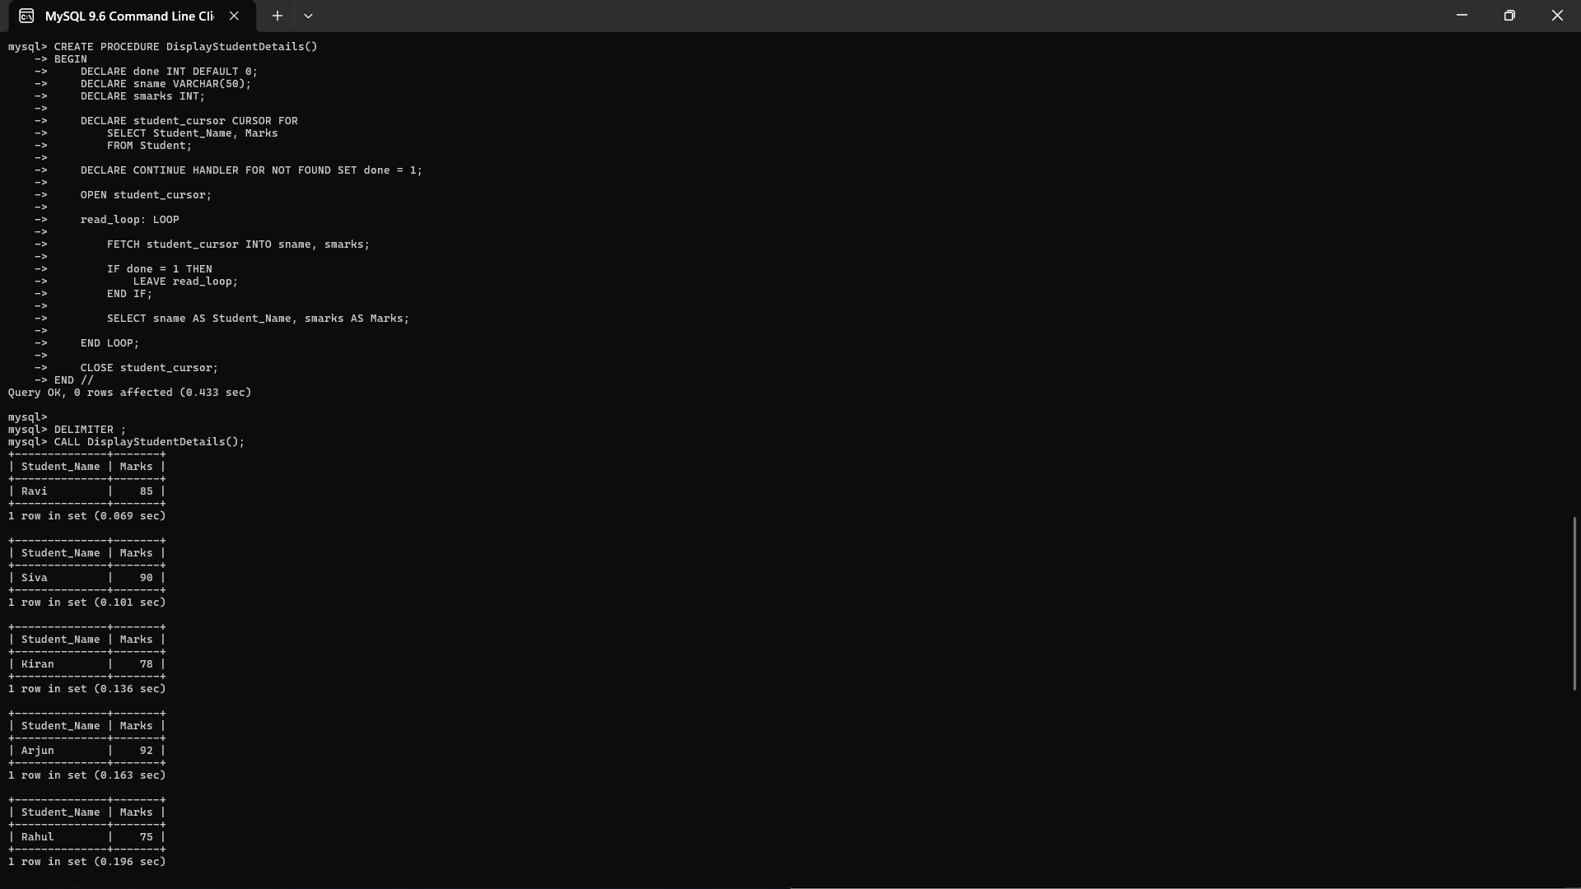

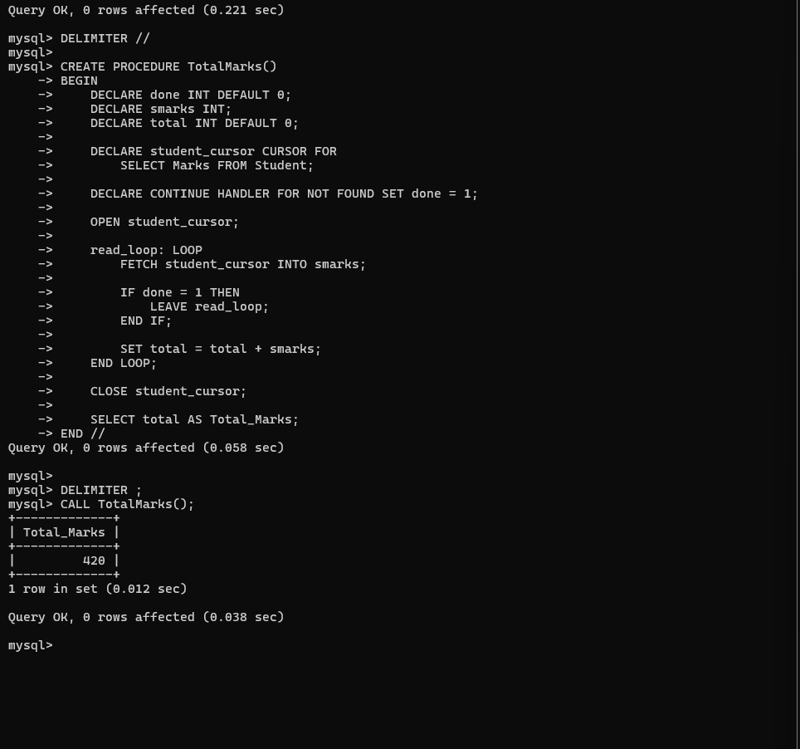

Result
Thus, the cursor was successfully created and implemented to retrieve and process records one row at a time from the Student table
Experiment:19 TRIGGER

Aim
To learn and implement Triggers in MySQL/MariaDB to automatically execute a specified block of SQL statements when an INSERT, UPDATE, or DELETE operation occurs on a table.

1. Create Database
CREATE DATABASE College;
USE College;
2. Create Student Table
CREATE TABLE Student (
Student_ID INT PRIMARY KEY,
Student_Name VARCHAR(50),
Department VARCHAR(30),
Marks INT
);
3. Insert Statements
INSERT INTO Student VALUES
(1, 'Ravi', 'CSE', 85),
(2, 'Siva', 'ECE', 90),
(3, 'Kiran', 'IT', 78);
Check Student Table
SELECT * FROM Student;
Output
Student_ID | Student_Name | Department | Marks
1 | Ravi | CSE | 85
2 | Siva | ECE | 90
3 | Kiran | IT | 78

4. Create Audit Table
The audit table stores the details of newly inserted students.
CREATE TABLE Student_Audit (
Audit_ID INT AUTO_INCREMENT PRIMARY KEY,
Student_ID INT,
Student_Name VARCHAR(50),
Action_Type VARCHAR(20)
);

5. Create Trigger
This trigger automatically inserts a record into Student_Audit whenever a new student is added.
Syntax
CREATE TRIGGER trigger_name
AFTER INSERT ON table_name
FOR EACH ROW
BEGIN
statements;
END;
Example
DELIMITER //

CREATE TRIGGER after_student_insert
AFTER INSERT ON Student
FOR EACH ROW
BEGIN
INSERT INTO Student_Audit
(Student_ID, Student_Name, Action_Type)
VALUES
(NEW.Student_ID, NEW.Student_Name, 'INSERT');
END //

DELIMITER ;

6. Test the Trigger
Insert a new student:
INSERT INTO Student
VALUES (4, 'Arjun', 'CSE', 92);
The trigger automatically executes.
Check Audit Table
SELECT * FROM Student_Audit;
Result
Audit_ID | Student_ID | Student_Name | Action_Type
1 | 4 | Arjun | INSERT
The Student_Audit record was created automatically by the trigger.

7. Another Example – UPDATE Trigger
Create another audit table:
CREATE TABLE Marks_Audit (
Audit_ID INT AUTO_INCREMENT PRIMARY KEY,
Student_ID INT,
Old_Marks INT,
New_Marks INT
);
Create the trigger:
DELIMITER //

CREATE TRIGGER after_marks_update
AFTER UPDATE ON Student
FOR EACH ROW
BEGIN
IF OLD.Marks <> NEW.Marks THEN
INSERT INTO Marks_Audit
(Student_ID, Old_Marks, New_Marks)
VALUES
(OLD.Student_ID, OLD.Marks, NEW.Marks);
END IF;
END //

DELIMITER ;
Update Student Marks
UPDATE Student
SET Marks = 95
WHERE Student_ID = 4;
Check Audit Table
SELECT * FROM Marks_Audit;
Result
Audit_ID | Student_ID | Old_Marks | New_Marks
1 | 4 | 92 | 95

Important Keywords
- NEW → Refers to the new value of a column.
- OLD → Refers to the previous value of a column.
- BEFORE → Trigger executes before the operation.
- AFTER → Trigger executes after the operation.
- INSERT → Trigger executes when a new row is inserted.
- UPDATE → Trigger executes when a row is updated.
- DELETE → Trigger executes when a row is deleted.
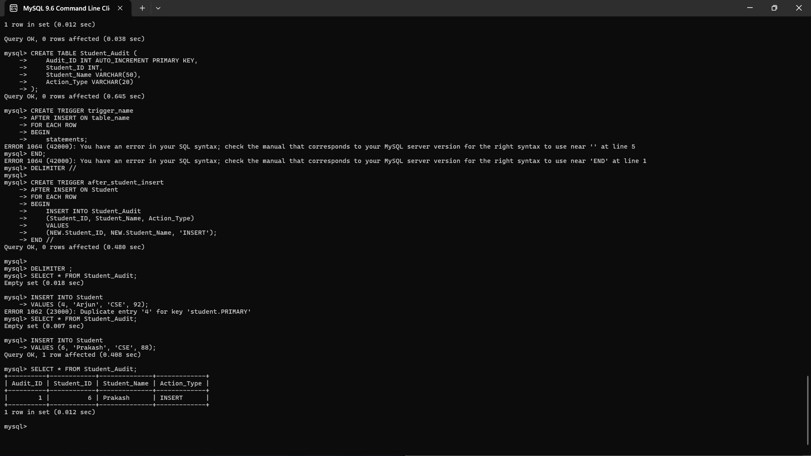
Result
Thus, the trigger was successfully created and implemented to automatically perform actions when INSERT and UPDATE operations are performed on the Student table.

Experiment: 20 MYSQL STRING FUNCTIONS- REPLACE, REPEAT,REVERSE,
RIGHT, LEFT, RPAD,LPAD

Aim
To study and implement the MySQL string functions REPLACE, REPEAT, REVERSE, RIGHT, LEFT, RPAD, and LPAD for manipulating string values.

1. Create Database
CREATE DATABASE College;
USE College;
2. Create Table
CREATE TABLE Student (
Student_ID INT PRIMARY KEY,
Student_Name VARCHAR(50),
Department VARCHAR(30)
);
3. Insert Statements
INSERT INTO Student VALUES
(1, 'Ravi Kumar', 'CSE'),
(2, 'Siva Kumar', 'ECE'),
(3, 'Kiran Kumar', 'IT'),
(4, 'Arjun Kumar', 'CSE'),
(5, 'Rahul Kumar', 'ECE');

4. REPLACE()
Purpose: Replaces a specified string with another string.
Syntax
REPLACE(string, old_string, new_string);
Example
SELECT REPLACE(Student_Name, 'Kumar', 'Reddy') AS New_Name
FROM Student;
Result
New_Name
Ravi Reddy
Siva Reddy
Kiran Reddy
Arjun Reddy
Rahul Reddy

5. REPEAT()
Purpose: Repeats a string a specified number of times.
Syntax
REPEAT(string, number);
Example
SELECT REPEAT('SQL ', 3) AS Result;
Result
Result
SQL SQL SQL

6. REVERSE()
Purpose: Reverses a string.
Syntax
REVERSE(string);
Example
SELECT REVERSE(Student_Name) AS Reverse_Name
FROM Student;
Result
Reverse_Name
ramuK ivaR
ramuK aviS
ramuK nariK
ramuK nujrA
ramuK luhaR

7. RIGHT()
Purpose: Returns a specified number of characters from the right side of a string.
Syntax
RIGHT(string, number);
Example
SELECT RIGHT(Student_Name, 5) AS Last_5_Characters
FROM Student;
Result
Last_5_Characters
Kumar
Kumar
Kumar
Kumar
Kumar

8. LEFT()
Purpose: Returns a specified number of characters from the left side of a string.
Syntax
LEFT(string, number);
Example
SELECT LEFT(Student_Name, 4) AS First_4_Characters
FROM Student;
Result
First_4_Characters
Ravi
Siva
Kira
Arju
R ahu

9. RPAD()
Purpose: Adds characters to the right side of a string until it reaches the specified length.
Syntax
RPAD(string, length, pad_string);
Example
SELECT RPAD(Student_Name, 15, '*') AS Padded_Name
FROM Student;
Result
Padded_Name
Ravi Kumar*****
Siva Kumar*****
Kiran Kumar****
Arjun Kumar****
Rahul Kumar****

10. LPAD()
Purpose: Adds characters to the left side of a string until it reaches the specified length.
Syntax
LPAD(string, length, pad_string);
Example
SELECT LPAD(Student_Name, 15, '*') AS Padded_Name
FROM Student;
Result
Padded_Name
*****Ravi Kumar
*****Siva Kumar
****Kiran Kumar
****Arjun Kumar
****Rahul Kumar

11. Combined Example Query
You can execute all the functions in a single query:
SELECT
Student_Name,
REPLACE(Student_Name, 'Kumar', 'Reddy') AS Replace_Name,
REPEAT('A', 3) AS Repeat_Result,
REVERSE(Student_Name) AS Reverse_Name,
RIGHT(Student_Name, 5) AS Right_Result,
LEFT(Student_Name, 4) AS Left_Result,
RPAD(Student_Name, 15, '*') AS Right_Padded,
LPAD(Student_Name, 15, '*') AS Left_Padded
FROM Student;
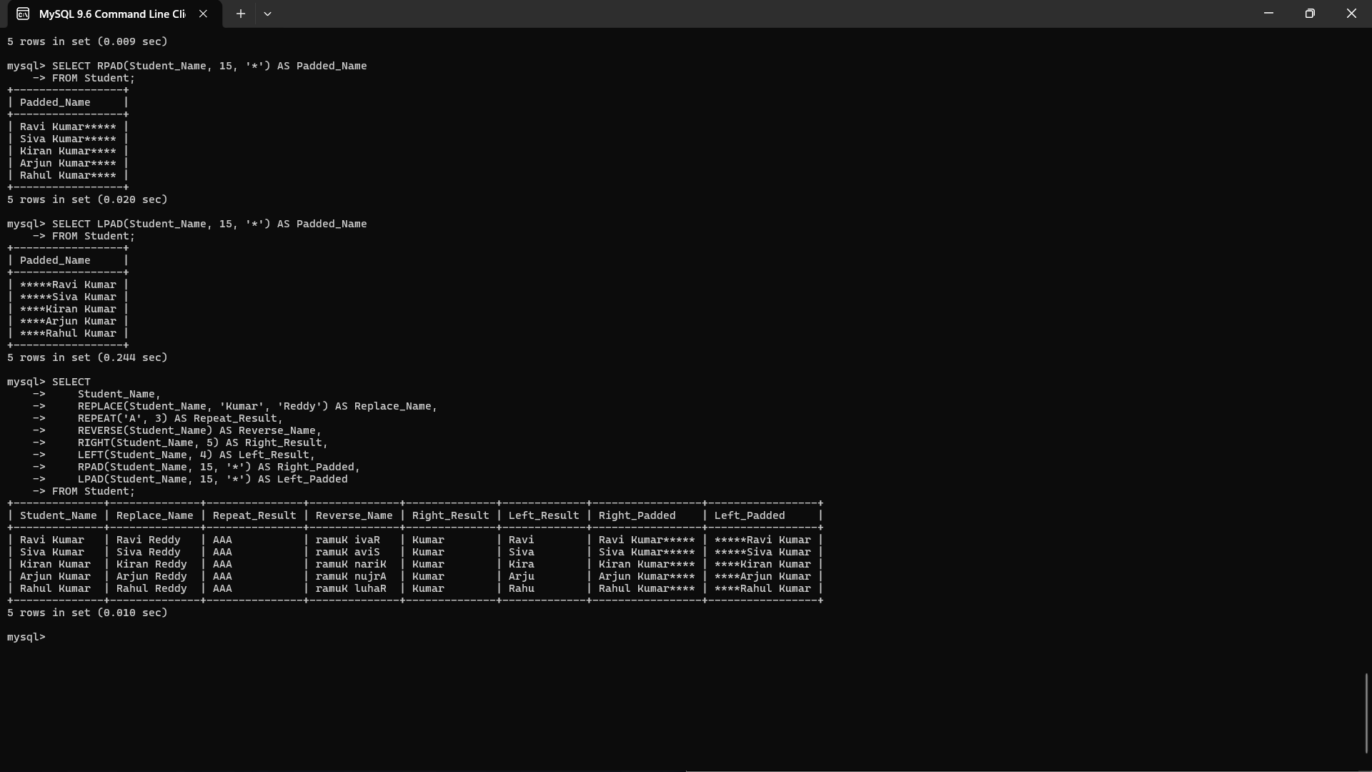

Result
Thus, the MySQL string functions REPLACE, REPEAT, REVERSE, RIGHT, LEFT, RPAD, and LPAD were successfully implemented to manipulate and format string values.

Experimert:21 MYSQL STRING FUNCTIONS- SPACE, SUBSTR,
UPPER, LOWER, TRIM, LENGTH

Aim
To study and implement the MySQL string functions SPACE, SUBSTR, UPPER, LOWER, TRIM, and LENGTH for manipulating and processing string values.

1. Create Database
CREATE DATABASE College;
USE College;
2. Create Table
CREATE TABLE Student (
Student_ID INT PRIMARY KEY,
Student_Name VARCHAR(50),
Department VARCHAR(30)
);
3. Insert Statements
INSERT INTO Student VALUES
(1, 'Ravi Kumar', 'CSE'),
(2, 'Siva Kumar', 'ECE'),
(3, 'Kiran Kumar', 'IT'),
(4, 'Arjun Kumar', 'CSE'),
(5, 'Rahul Kumar', 'ECE');
Check the table:
SELECT * FROM Student;

4. SPACE()
Purpose: Returns a string containing the specified number of spaces.
Syntax
SPACE(number);
Example
SELECT CONCAT('Hello', SPACE(5), 'World') AS Result;
Result
Hello World

5. SUBSTR()
Purpose: Extracts a part of a string.
Syntax
SUBSTR(string, start_position, length);
Example
SELECT SUBSTR(Student_Name, 1, 4) AS First_Four
FROM Student;
Result
First_Four
Ravi
Siva
Kira
Arju
R ahu

6. UPPER()
Purpose: Converts a string into uppercase letters.
Syntax
UPPER(string);
Example
SELECT UPPER(Student_Name) AS Upper_Name
FROM Student;
Result
Upper_Name
RAVI KUMAR
SIVA KUMAR
KIRAN KUMAR
ARJUN KUMAR
RAHUL KUMAR

7. LOWER()
Purpose: Converts a string into lowercase letters.
Syntax
LOWER(string);
Example
SELECT LOWER(Student_Name) AS Lower_Name
FROM Student;
Result
Lower_Name
ravi kumar
siva kumar
kiran kumar
arjun kumar
rahul kumar

8. TRIM()
Purpose: Removes leading and trailing spaces from a string.
Syntax
TRIM(string);
Example
SELECT TRIM(' Hello World ') AS Trimmed_String;
Result
Trimmed_String
Hello World
You can also use it with a table:
SELECT TRIM(Student_Name) AS Trimmed_Name
FROM Student;

9. LENGTH()
Purpose: Returns the length of a string in bytes.
Syntax
LENGTH(string);
Example
SELECT Student_Name, LENGTH(Student_Name) AS Name_Length
FROM Student;
Result
Student_Name | Name_Length
Ravi Kumar | 10
Siva Kumar | 10
Kiran Kumar | 11
Arjun Kumar | 11
Rahul Kumar | 11
10. Combined Example Query
You can execute all the functions in one query:
SELECT
Student_Name,
SPACE(3) AS Spaces,
SUBSTR(Student_Name, 1, 4) AS Substring,
UPPER(Student_Name) AS Upper_Name,
LOWER(Student_Name) AS Lower_Name,
TRIM(Student_Name) AS Trimmed_Name,
LENGTH(Student_Name) AS Name_Length
FROM Student;
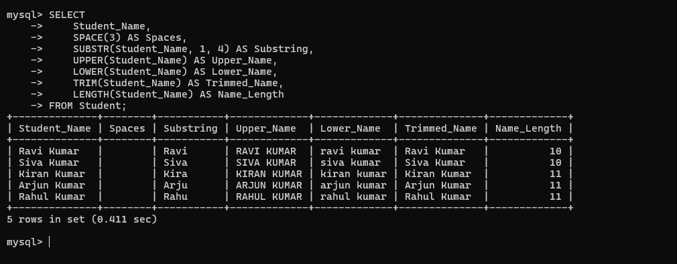
Result
Thus, the MySQL string functions SPACE, SUBSTR, UPPER, LOWER, TRIM, and LENGTH were successfully implemented to manipulate, extract, format, and analyze string values.

Experiment: 22 DATABASE CONNECTIVITY USING PHP AND
MYSQL
Aim
To establish a connection between PHP and MySQL and perform basic database operations using PHP.

1. Create Database in MySQL
CREATE DATABASE College;
USE College;
2. Create Table
CREATE TABLE Student (
Student_ID INT PRIMARY KEY,
Student_Name VARCHAR(50),
Department VARCHAR(30),
Marks INT
);
3. Insert Records
INSERT INTO Student VALUES
(1, 'Ravi', 'CSE', 85),
(2, 'Siva', 'ECE', 90),
(3, 'Kiran', 'IT', 78),
(4, 'Arjun', 'CSE', 92),
(5, 'Rahul', 'ECE', 75);
Check the records:
SELECT * FROM Student;

4. PHP–MySQL Connection
Create a file named dbconnect.php.
<?php

$servername = "localhost";
$username = "root";
$password = "";
$database = "College";

$conn = mysqli_connect($servername, $username, $password, $database);

if (!$conn) {
die("Connection failed: " . mysqli_connect_error());
}

echo "Database connected successfully!";

?>
Explanation
- localhost → MySQL server running on the local computer.
- root → MySQL username.
- "" → MySQL password. Change it if your MySQL has a password.
- College → Database name.
- mysqli_connect() → Establishes the connection.
- mysqli_connect_error() → Displays connection errors.

5. PHP Program to Display Student Records
Create students.php:
<?php

$servername = "localhost";
$username = "root";
$password = "";
$database = "College";

$conn = mysqli_connect($servername, $username, $password, $database);

if (!$conn) {
die("Connection failed: " . mysqli_connect_error());
}

$sql = "SELECT * FROM Student";

$result = mysqli_query($conn, $sql);

echo "<h2>Student Details</h2>";

echo "<table border='1' cellpadding='8'>";
echo "<tr>";
echo "<th>Student ID</th>";
echo "<th>Student Name</th>";
echo "<th>Department</th>";
echo "<th>Marks</th>";
echo "</tr>";

while ($row = mysqli_fetch_assoc($result)) {
echo "<tr>";
echo "<td>" . $row["Student_ID"] . "</td>";
echo "<td>" . $row["Student_Name"] . "</td>";
echo "<td>" . $row["Department"] . "</td>";
echo "<td>" . $row["Marks"] . "</td>";
echo "</tr>";
}

echo "</table>";

mysqli_close($conn);

?>

6. Expected Output
When you run students.php in the browser:
Student ID | Student Name | Department | Marks
1 | Ravi | CSE | 85
2 | Siva | ECE | 90
3 | Kiran | IT | 78
4 | Arjun | CSE | 92
5 | Rahul | ECE | 75

7. Simple Insert Using PHP
You can also insert a new student through PHP:
<?php

$conn = mysqli_connect("localhost", "root", "", "College");

if (!$conn) {
die("Connection failed");
}

$sql = "INSERT INTO Student
VALUES (6, 'Prakash', 'CSE', 88)";

if (mysqli_query($conn, $sql)) {
echo "Student inserted successfully";
} else {
echo "Error: " . mysqli_error($conn);
}

mysqli_close($conn);

?>
Result
Student inserted successfully
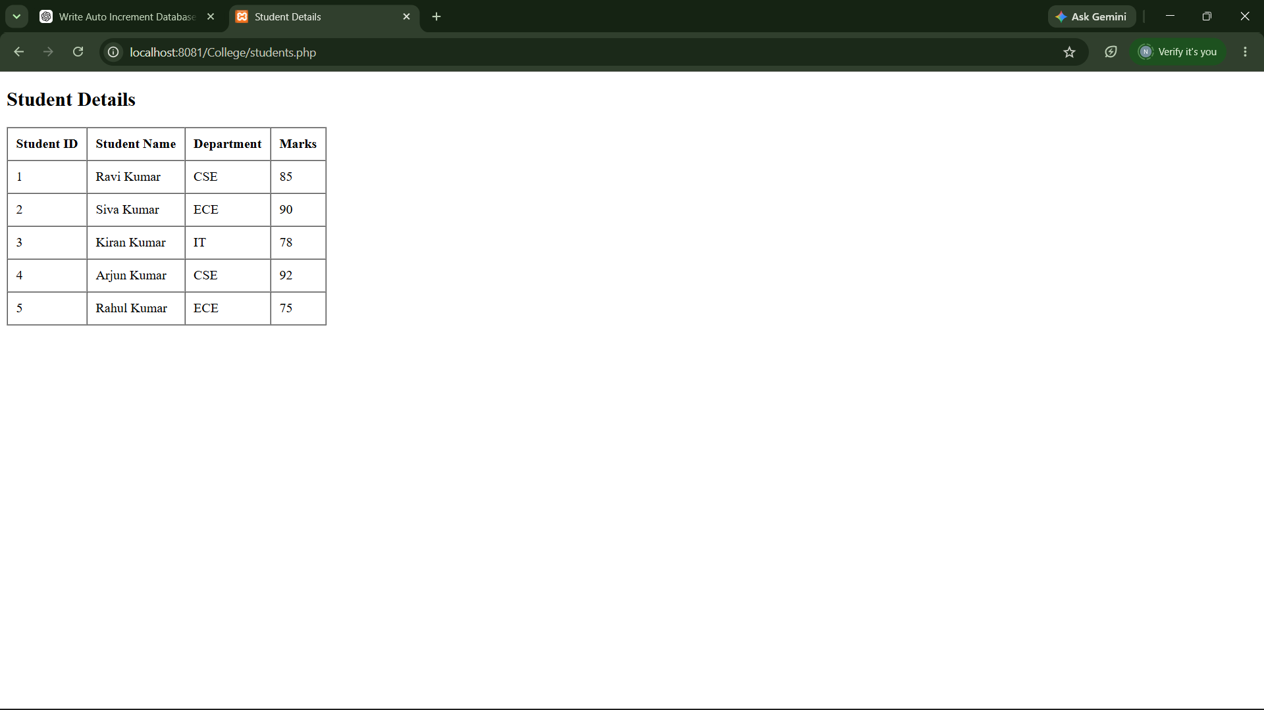
Result
Thus, PHP was successfully connected with the MySQL database, and student records were retrieved and inserted using PHP and MySQL connectivity.

Experiment:23 TRAIN TICKET RESERVATION SYSTEM TO RECEIVE TICKETS THROUGH SOCIAL NETWORK
Aim
To develop a Train Ticket Reservation System that allows users to search for trains, reserve tickets, and receive booking/ticket details through a social network or messaging platform.
Objective
- To store passenger and train details in a database.
- To allow users to search available trains.
- To reserve train tickets.
- To generate a unique ticket/PNR number.
- To send the reservation details through a social network or messaging service.
- To maintain booking and passenger records.

1. Database Creation
CREATE DATABASE TrainReservation;
USE TrainReservation;
2. Create Train Table
CREATE TABLE Train (
Train_ID INT PRIMARY KEY AUTO_INCREMENT,
Train_Name VARCHAR(50),
Source VARCHAR(50),
Destination VARCHAR(50),
Journey_Date DATE,
Available_Seats INT
);
3. Insert Train Details
INSERT INTO Train
(Train_Name, Source, Destination, Journey_Date, Available_Seats)
VALUES
('Charminar Express', 'Hyderabad', 'Chennai', '2026-08-25', 100),
('Godavari Express', 'Hyderabad', 'Visakhapatnam', '2026-08-25', 80),
('Krishna Express', 'Hyderabad', 'Tirupati', '2026-08-26', 75);

4. Create Passenger Table
CREATE TABLE Passenger (
Passenger_ID INT PRIMARY KEY AUTO_INCREMENT,
Passenger_Name VARCHAR(50),
Age INT,
Gender VARCHAR(10),
Phone VARCHAR(15),
Social_ID VARCHAR(100)
);
5. Create Reservation Table
CREATE TABLE Reservation (
Booking_ID INT PRIMARY KEY AUTO_INCREMENT,
Passenger_ID INT,
Train_ID INT,
Journey_Date DATE,
Seat_No INT,
PNR VARCHAR(20) UNIQUE,
Booking_Status VARCHAR(20),
FOREIGN KEY (Passenger_ID) REFERENCES Passenger(Passenger_ID),
FOREIGN KEY (Train_ID) REFERENCES Train(Train_ID)
);

6. Insert Passenger
INSERT INTO Passenger
(Passenger_Name, Age, Gender, Phone, Social_ID)
VALUES
('Ravi Kumar', 21, 'Male', '9876543210', 'ravi_social01');

7. Reserve Ticket
Suppose passenger 1 wants to book train 1.
INSERT INTO Reservation
(Passenger_ID, Train_ID, Journey_Date, Seat_No, PNR, Booking_Status)
VALUES
(1, 1, '2026-08-25', 25, 'PNR10001', 'CONFIRMED');

8. Update Available Seats
UPDATE Train
SET Available_Seats = Available_Seats - 1
WHERE Train_ID = 1;

9. Display Ticket Details
SELECT
r.PNR,
p.Passenger_Name,
p.Age,
p.Gender,
t.Train_Name,
t.Source,
t.Destination,
r.Journey_Date,
r.Seat_No,
r.Booking_Status
FROM Reservation r
JOIN Passenger p
ON r.Passenger_ID = p.Passenger_ID
JOIN Train t
ON r.Train_ID = t.Train_ID;
Result
PNR | Passenger | Train | Source | Destination | Seat | Status
PNR10001 | Ravi Kumar | Charminar Express | Hyderabad | Chennai | 25 | CONFIRMED

10. Social Network Ticket Delivery
The application can use the passenger's registered phone number or social-network ID to send the ticket.
Process
User
↓
Social Network / Messaging Platform
↓
Reservation Application
↓
Search Train
↓
Enter Passenger Details
↓
Check Seat Availability
↓
Book Ticket
↓
Generate PNR
↓
Store in MySQL Database
↓
Send Ticket Details
↓
Passenger receives ticket
Example Message
TRAIN TICKET CONFIRMATION

PNR: PNR10001
Passenger: Ravi Kumar
Train: Charminar Express
From: Hyderabad
To: Chennai
Journey Date: 25-08-2026
Seat No: 25
Status: CONFIRMED

Thank you for using Train Ticket Reservation System.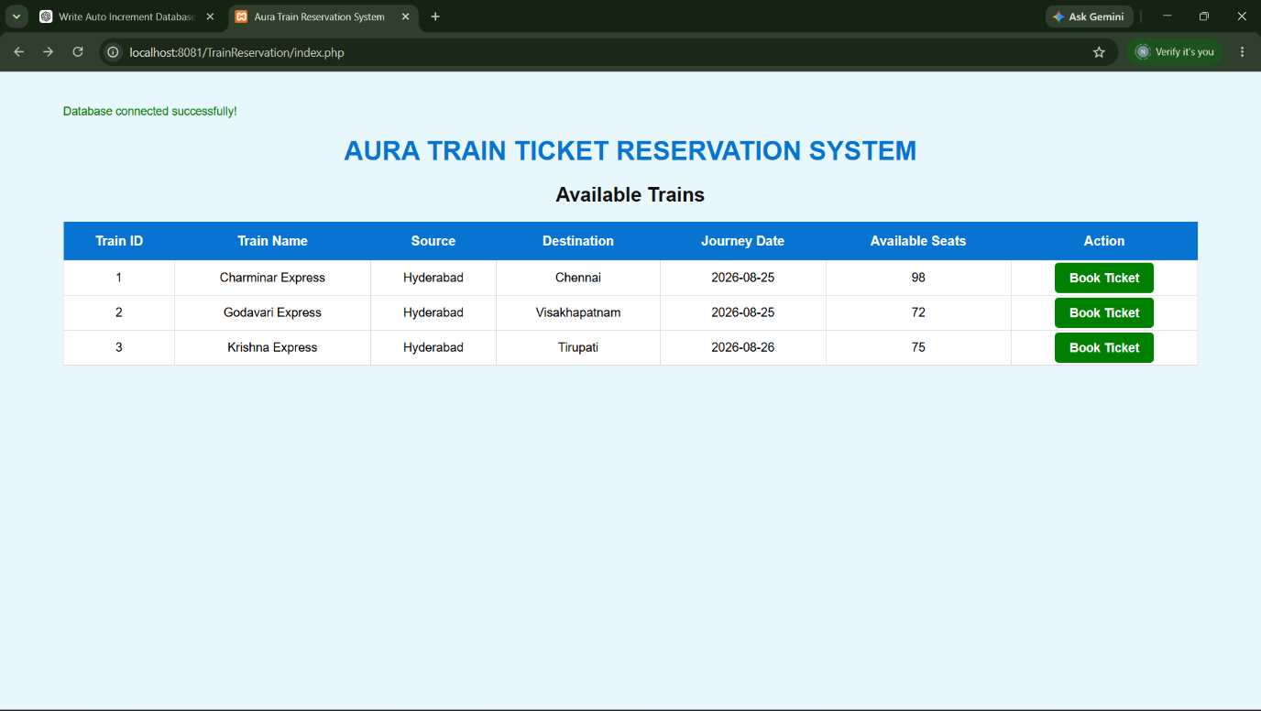
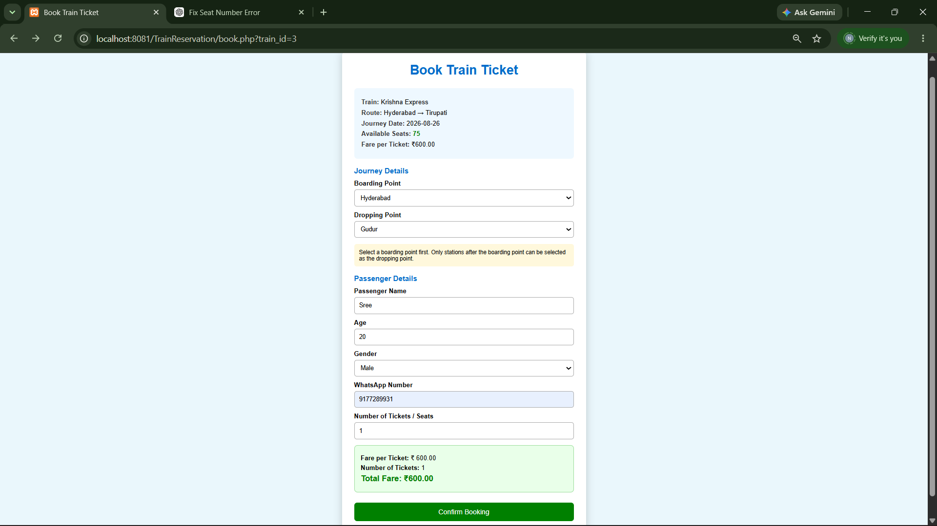
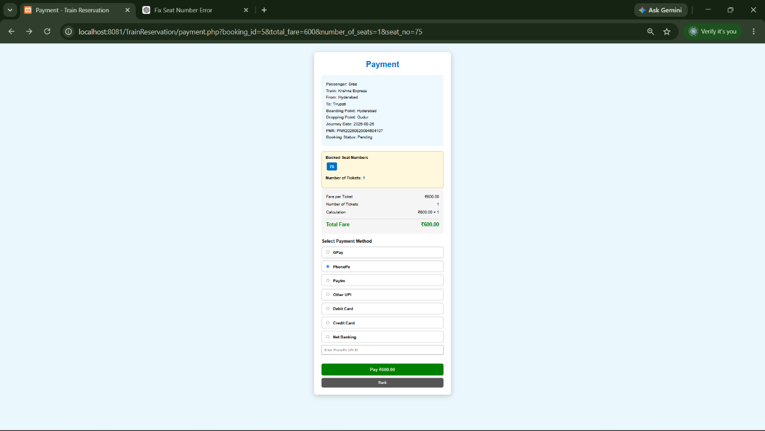
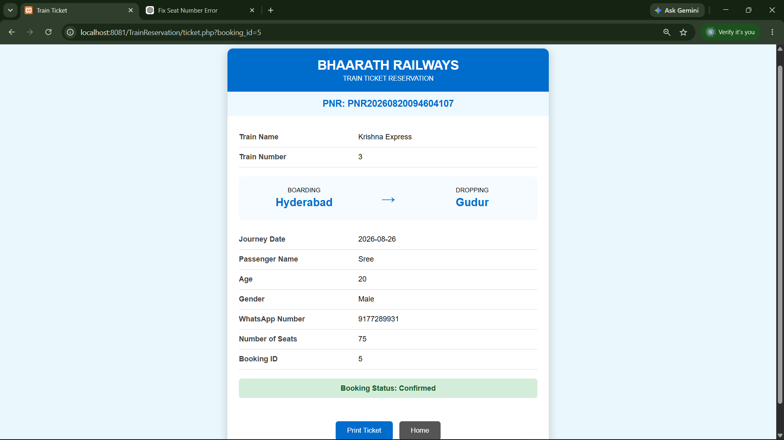

Result
Thus, a Train Ticket Reservation System was designed using MySQL to store train, passenger, and reservation details, generate a PNR, update seat availability, and provide ticket information that can be delivered to the passenger through a social-network/messaging interface.

1. COLLEGE ADMISSION MANAGEMENT SYSTEM
AIM
To design and implement a College Admission Management System using MySQL to store student details, courses, admission information, and fees, and to perform various database operations such as insertion, retrieval, updating, deletion, and joining of records.
SQL CODE
Step 1: Create Database
CREATE DATABASE CollegeAdmission;
USE CollegeAdmission;
Step 2: Create Student Table
CREATE TABLE Students (
student_id INT PRIMARY KEY AUTO_INCREMENT,
student_name VARCHAR(100) NOT NULL,
gender VARCHAR(10),
dob DATE,
phone VARCHAR(15),
email VARCHAR(100),
address VARCHAR(200)
);
Step 3: Create Course Table
CREATE TABLE Courses (
course_id INT PRIMARY KEY AUTO_INCREMENT,
course_name VARCHAR(100) NOT NULL,
department VARCHAR(100),
duration INT,
total_fee DECIMAL(10,2)
);
Step 4: Create Admission Table
CREATE TABLE Admissions (
admission_id INT PRIMARY KEY AUTO_INCREMENT,
student_id INT,
course_id INT,
admission_date DATE,
admission_status VARCHAR(30),
FOREIGN KEY (student_id) REFERENCES Students(student_id),
FOREIGN KEY (course_id) REFERENCES Courses(course_id)
);
Step 5: Insert Student Details
INSERT INTO Students
(student_name, gender, dob, phone, email, address)
VALUES
('Tharun Kumar', 'Male', '2007-05-15',
'9876543210', 'tharun@gmail.com', 'Hyderabad'),

('Rahul Sharma', 'Male', '2006-08-20',
'9876501234', 'rahul@gmail.com', 'Vijayawada'),

('Priya Reddy', 'Female', '2007-02-10',
'9988776655', 'priya@gmail.com', 'Tirupati');
Step 6: Insert Course Details
INSERT INTO Courses
(course_name, department, duration, total_fee)
VALUES
('B.Tech Computer Science', 'CSE', 4, 150000),
('B.Tech Information Technology', 'IT', 4, 140000),
('B.Tech Electronics and Communication', 'ECE', 4, 130000);
Step 7: Insert Admission Details
INSERT INTO Admissions
(student_id, course_id, admission_date, admission_status)
VALUES
(1, 1, '2026-08-22', 'Confirmed'),
(2, 2, '2026-08-22', 'Confirmed'),
(3, 3, '2026-08-22', 'Pending');
SQL QUERIES
1. Display all students
SELECT * FROM Students;
RESULT
student_id | student_name | gender | phone | email
1 | Tharun Kumar | Male | 9876543210 | tharun@gmail.com
2 | Rahul Sharma | Male | 9876501234 | rahul@gmail.com
3 | Priya Reddy | Female | 9988776655 | priya@gmail.com

2. Display available courses
SELECT * FROM Courses;
RESULT
course_id | course_name | department | duration | total_fee
1 | B.Tech Computer Science | CSE | 4 | 150000
2 | B.Tech Information Technology | IT | 4 | 140000
3 | B.Tech Electronics and Communication | ECE | 4 | 130000

3. Display complete admission details
SELECT
a.admission_id,
s.student_name,
c.course_name,
c.department,
a.admission_date,
a.admission_status
FROM Admissions a
JOIN Students s
ON a.student_id = s.student_id
JOIN Courses c
ON a.course_id = c.course_id;
RESULT
admission_id | student_name | course_name | department | admission_status
1 | Tharun Kumar | B.Tech Computer Science | CSE | Confirmed
2 | Rahul Sharma | B.Tech Information Technology | IT | Confirmed
3 | Priya Reddy | B.Tech Electronics and Communication | ECE | Pending

4. Find confirmed admissions
SELECT
s.student_name,
c.course_name,
a.admission_status
FROM Admissions a
JOIN Students s
ON a.student_id = s.student_id
JOIN Courses c
ON a.course_id = c.course_id
WHERE a.admission_status = 'Confirmed';

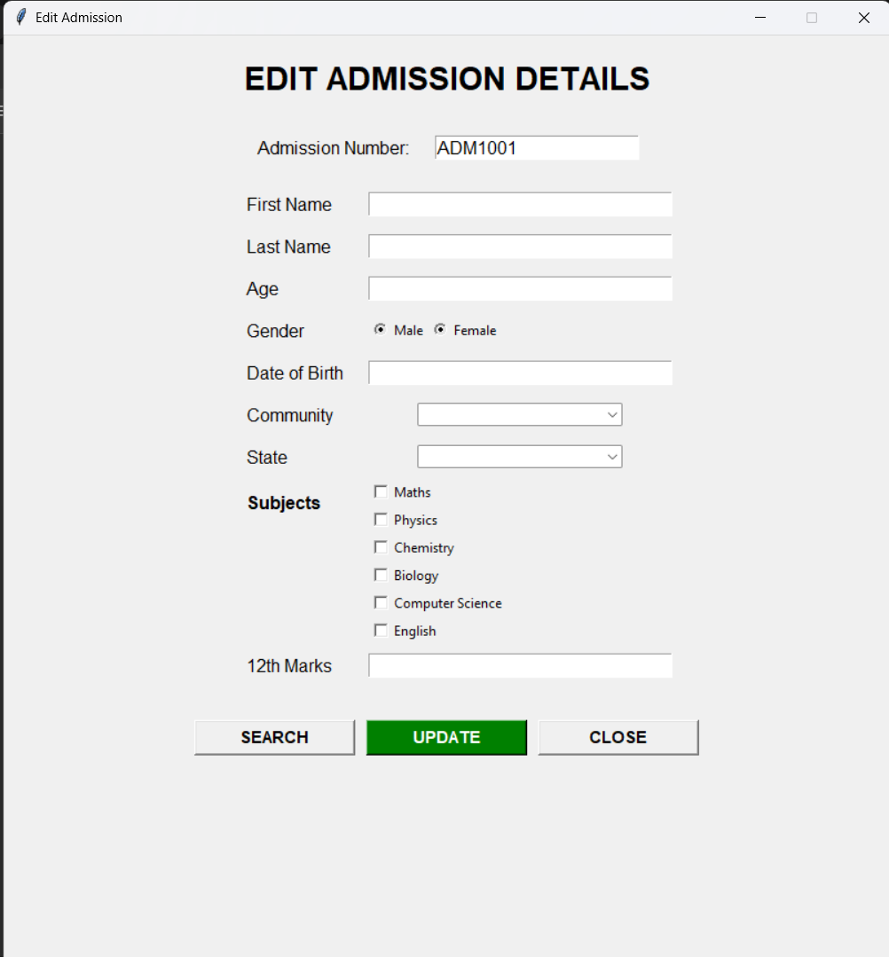
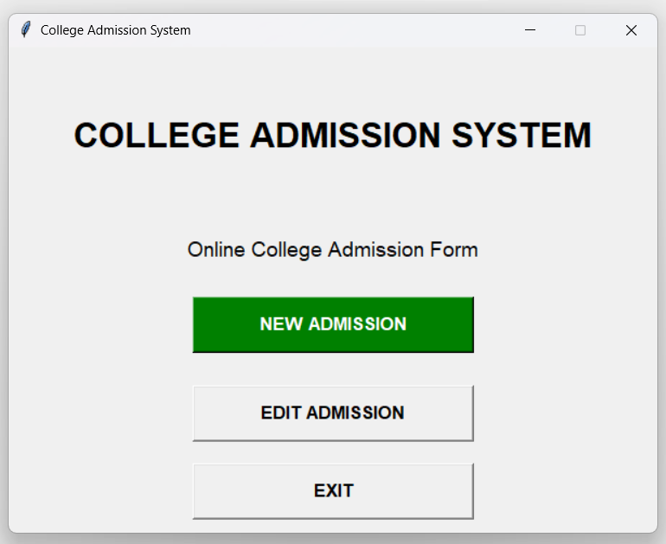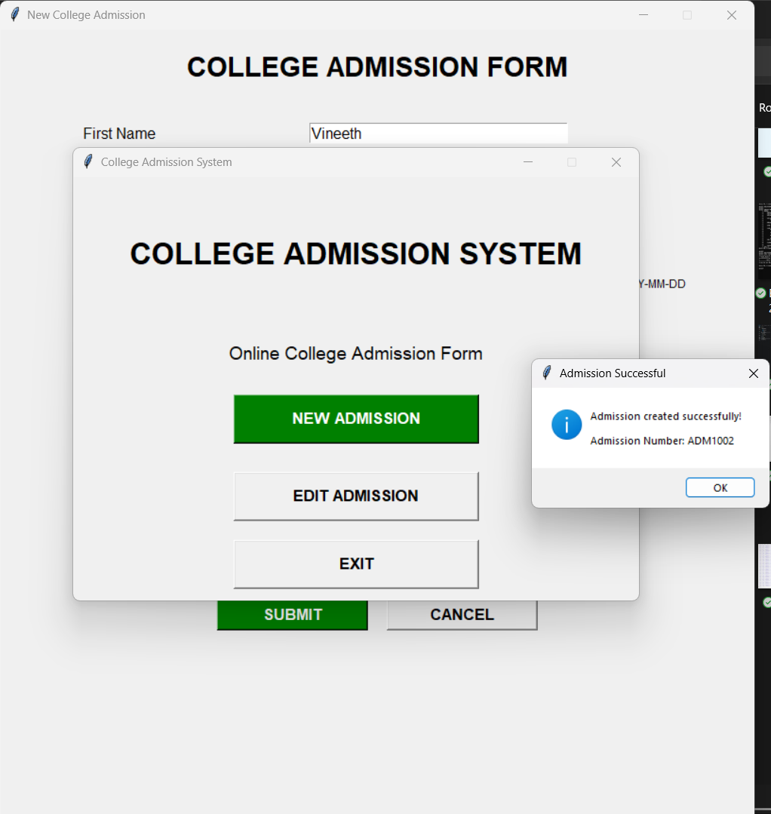
RESULT
Tharun Kumar B.Tech Computer Science Confirmed
Rahul Sharma B.Tech Information Technology Confirmed

5. Update admission status
UPDATE Admissions
SET admission_status = 'Confirmed'
WHERE admission_id = 3;
RESULT
Query OK
1 row affected

6. Count total students
SELECT COUNT(*) AS Total_Students
FROM Students;
RESULT
Total_Students
--------------
3

2. QR-ENABLED AUTOMATIC BUS TICKET BOOKING SYSTEM
AIM
To develop a QR-Enabled Automatic Bus Ticket Booking System using MySQL that allows users to select buses and seats, make a booking, store passenger and payment details, generate a unique PNR, and generate a QR code containing the ticket information.
SQL CODE
Step 1: Create Database
CREATE DATABASE QRBusTicket;
USE QRBusTicket;
Step 2: Create Users Table
CREATE TABLE Users (
user_id INT PRIMARY KEY AUTO_INCREMENT,
full_name VARCHAR(100) NOT NULL,
phone VARCHAR(15) UNIQUE NOT NULL,
email VARCHAR(100),
password VARCHAR(100) NOT NULL
);
Step 3: Create Buses Table
CREATE TABLE Buses (
bus_id INT PRIMARY KEY AUTO_INCREMENT,
bus_name VARCHAR(100) NOT NULL,
source VARCHAR(100) NOT NULL,
destination VARCHAR(100) NOT NULL,
journey_date DATE NOT NULL,
fare DECIMAL(10,2) NOT NULL,
total_seats INT DEFAULT 40
);
Step 4: Create Bookings Table
CREATE TABLE Bookings (
booking_id INT PRIMARY KEY AUTO_INCREMENT,
pnr VARCHAR(30) UNIQUE NOT NULL,
user_id INT NOT NULL,
bus_id INT NOT NULL,
passenger_name VARCHAR(100) NOT NULL,
phone VARCHAR(15) NOT NULL,
seat_number VARCHAR(20) NOT NULL,
fare DECIMAL(10,2) NOT NULL,
payment_method VARCHAR(50),
payment_status VARCHAR(30),
booking_time DATETIME DEFAULT CURRENT_TIMESTAMP,

FOREIGN KEY (user_id)
REFERENCES Users(user_id),

FOREIGN KEY (bus_id)
REFERENCES Buses(bus_id),

UNIQUE(bus_id, journey_date, seat_number)
);
Important: If your MySQL version does not have journey_date in Bookings, use this corrected version instead:
CREATE TABLE Bookings (
booking_id INT PRIMARY KEY AUTO_INCREMENT,
pnr VARCHAR(30) UNIQUE NOT NULL,
user_id INT NOT NULL,
bus_id INT NOT NULL,
passenger_name VARCHAR(100) NOT NULL,
phone VARCHAR(15) NOT NULL,
journey_date DATE NOT NULL,
seat_number VARCHAR(20) NOT NULL,
fare DECIMAL(10,2) NOT NULL,
payment_method VARCHAR(50),
payment_status VARCHAR(30),
booking_time DATETIME DEFAULT CURRENT_TIMESTAMP,

FOREIGN KEY (user_id)
REFERENCES Users(user_id),

FOREIGN KEY (bus_id)
REFERENCES Buses(bus_id),

UNIQUE(bus_id, journey_date, seat_number)
);
Step 5: Insert User
INSERT INTO Users
(full_name, phone, email, password)
VALUES
('Tharun Kumar', '9177289931',
'tharun@gmail.com', '123456');
Step 6: Insert Bus Details
INSERT INTO Buses
(bus_name, source, destination, journey_date, fare, total_seats)
VALUES
('Krishna Travels',
'Vijayawada',
'Tirupati',
'2026-08-22',
600,
40),

('APSRTC Express',
'Vijayawada',
'Hyderabad',
'2026-08-22',
450,
40),

('Orange Travels',
'Hyderabad',
'Vijayawada',
'2026-08-22',
550,
40);

BUS BOOKING QUERIES
1. Display available buses
SELECT
bus_id,
bus_name,
source,
destination,
journey_date,
fare,
total_seats
FROM Buses;
RESULT
bus_id | bus_name | source | destination | fare
1 | Krishna Travels | Vijayawada | Tirupati | ₹600
2 | APSRTC Express | Vijayawada | Hyderabad | ₹450
3 | Orange Travels | Hyderabad | Vijayawada | ₹550

2. Book six seats
For example:
INSERT INTO Bookings
(pnr, user_id, bus_id, passenger_name, phone,
journey_date, seat_number, fare,
payment_method, payment_status)
VALUES
('BUS8K4P21A', 1, 1, 'Tharun Kumar', '9177289931',
'2026-08-22', 'Seat 1', 600, 'GPay', 'PAID'),

('BUS8K4P21B', 1, 1, 'Tharun Kumar', '9177289931',
'2026-08-22', 'Seat 2', 600, 'GPay', 'PAID'),

('BUS8K4P21C', 1, 1, 'Tharun Kumar', '9177289931',
'2026-08-22', 'Seat 5', 600, 'GPay', 'PAID'),

('BUS8K4P21D', 1, 1, 'Tharun Kumar', '9177289931',
'2026-08-22', 'Seat 6', 600, 'GPay', 'PAID'),

('BUS8K4P21E', 1, 1, 'Tharun Kumar', '9177289931',
'2026-08-22', 'Seat 7', 600, 'GPay', 'PAID'),

('BUS8K4P21F', 1, 1, 'Tharun Kumar', '9177289931',
'2026-08-22', 'Seat 8', 600, 'GPay', 'PAID');
RESULT
6 tickets booked successfully.

Seats:
Seat 1
Seat 2
Seat 5
Seat 6
Seat 7
Seat 8

Fare per ticket: ₹600
Total Amount: ₹3600
Payment Status: PAID
Payment Method: GPay

3. Display booked seats
SELECT
seat_number,
pnr,
payment_status
FROM Bookings
WHERE bus_id = 1
AND journey_date = '2026-08-22';
RESULT
seat_number | pnr | payment_status
Seat 1 | BUS8K4P21A | PAID
Seat 2 | BUS8K4P21B | PAID
Seat 5 | BUS8K4P21C | PAID
Seat 6 | BUS8K4P21D | PAID
Seat 7 | BUS8K4P21E | PAID
Seat 8 | BUS8K4P21F | PAID

4. Display complete ticket details
SELECT
b.pnr,
u.full_name,
b.phone,
bs.bus_name,
bs.source,
bs.destination,
b.journey_date,
b.seat_number,
b.fare,
b.payment_method,
b.payment_status
FROM Bookings b
JOIN Users u
ON b.user_id = u.user_id
JOIN Buses bs
ON b.bus_id = bs.bus_id
WHERE b.user_id = 1;
RESULT
PNR : BUS8K4P21A
Passenger : Tharun Kumar
Phone : 9177289931
Bus : Krishna Travels
Route : Vijayawada → Tirupati
Journey Date : 2026-08-22
Seat : Seat 1
Fare : ₹600
Payment : GPay
Status : PAID

5. Calculate total amount
SELECT
COUNT(*) AS Total_Tickets,
SUM(fare) AS Total_Amount
FROM Bookings
WHERE user_id = 1
AND bus_id = 1
AND journey_date = '2026-08-22'
AND payment_status = 'PAID';
RESULT
Total_Tickets Total_Amount
------------- ------------
6 ₹3600

3. QR CODE GENERATION
The QR code can be generated in Python after successful payment.
Python Code
import qrcode

ticket_data = """
QR ENABLED BUS TICKET

PNR: BUS8K4P21A
Passenger: Tharun Kumar
Phone: 9177289931

Bus: Krishna Travels
From: Vijayawada
To: Tirupati

Journey Date: 2026-08-22

Seats:
Seat 1
Seat 2
Seat 5
Seat 6
Seat 7
Seat 8

Total Tickets: 6
Fare Per Ticket: ₹600
Total Amount: ₹3600

Payment Method: GPay
Payment Status: PAID
"""

qr = qrcode.QRCode(
version=1,
error_correction=qrcode.constants.ERROR_CORRECT_H,
box_size=10,
border=4
)

qr.add_data(ticket_data)
qr.make(fit=True)

qr_image = qr.make_image(
fill_color="black",
back_color="white"
)

qr_image.save("bus_ticket_QR.png")

print("QR Code Generated Successfully")
